“Women Safety App with SOS and Live Tracking”
A Project Report Submitted in the partial fulfillment of the requirements for the award of the degree of

BACHELOROFTECHNOLOGY
In
DEPARTMENT OF COMPUTER SCIENCE ENGINNERING
&
DEPARTMENT OF COMPUTER SCIENCE AND INFORMATION TECHNOLOGY By
MANDAPATI KEERTHI | :2520030079
NARNE GREESHMA | :2520030080
P. YASWANTH SURYA | :2520030581
Under the Esteemed Guidance of
Dr Yerragudipadu Subbarayudu
Assistant Professor

Department of Computer Science and Engineering

K L (Deemed to be) University DEPARTMENT OF COMPUTER SCIENCE ENGINEERING

Declaration
The Project Report entitled “Women Safety App with SOS and Live Tracking” is a record of Bonafide work of MANDAPATI KEERTHI SRI - 2520030079, NARNE GREESHMA - 2520030080, P.YASWANTH SURYA- 2520030581 submitted in partial fulfilment for the award of B. Tech in Computer Science and Engineering (or) Computer Science and Information Technology to the K L University. The results embodied in this report have not been copied from any other departments/University/Institute.
MANDAPATI KEERTHI – 252030079
NARNE GREESHMA – 2520030080 YASWANTH SURYA – 2520030581

K L (Deemed to be) University
DEPARTMENT OF COMPUTER SCIENCE ENGINEERING

CERTIFICATE
This is certify that the mini project based report entitled “Women Safety App with SOS and Live Tracking” is a
Bonafide work done and submitted by MANDAPATI KEERTHI – 2520030079 , NARNE GREESHMA - 2520030080, P. YASWANTH SURYA- 2520030581
in partial fulfilment of the requirements for the award of the degree of BACHELOR OF TECHNOLOGY in Department of Computer Science Engineering, K L (Deemed to be University), during the academic year 2026-2027.
Signature of the Guide
Signature of the Course Coordinator Signature of the HOD

ACKNOWLEDGEMENT
The success in this project would not have been possible but for the timely help and guidance rendered by many people. Our wish to express my sincere thanks to all those who has assisted us in one way or the other for the completion of my project.
Our greatest appreciation to my Course Coordinator Dr Yerragudipadu Subbarayudu, and my guide Dr Yerragudipadu Subbarayudu, Department of Computer Science which cannot be expressed in words for his/her tremendous support, encouragement and guidance for this project.
We express our gratitude to Dr. P Venkateshwara Rao (CSE), Head of the Department for Computer Science Engineering for providing us with adequate facilities, ways and means by which we are able to complete this project-based Lab.
We thank all the members of teaching and non-teaching staff members, and also who have assisted me directly or indirectly for successful completion of this project. Finally, I sincerely thank my parents, friends and classmates for their kind help and cooperation during my work.
MANDAPATI KEERTHI – 252030079
NARNE GREESHMA – 2520030080. YASWANTH SURYA – 2520030581

Abstract
Women’s safety remains a major concern in today’s society, especially during situations involving harassment, emergencies, or unsafe travel. In critical moments, manually making a phone call or sending a message can be difficult and time-consuming, while conventional safety applications may require multiple actions before help can be requested. To tackle this, our project focuses on the Design and Development of a Women Safety Application with SOS Alert and Live Location Tracking. Our core aim was to successfully implement a reliable and easy-to-use mobile application that enables women to quickly request emergency assistance and share their real-time location with trusted guardians.
The application is structured around multiple interconnected safety modules. It provides Guardian Setup for adding and managing trusted emergency contacts, along with an SOS Trigger Module that can activate an emergency alert through a shake gesture or predefined power-button pattern. Once activated, the system automatically shares the user's current location with registered guardians and provides essential emergency communication through SMS and phone calls. The application also includes continuous Live Location Tracking, allowing guardians to monitor the user's movement during an emergency situation. Additional features such as Evidence Capture enable the user to record audio or capture photographs when required, while Safe Route Suggestions help users identify safer travel routes.
The most important feature of the application is its ability to initiate a silent SOS alert quickly without requiring the user to navigate through the application during a dangerous situation. The system uses Android (Kotlin), Fused Location API, Firebase, Twilio SMS API, and Shake Detection technologies to provide fast and reliable emergency assistance. By combining automatic alerts, real-time location sharing, emergency communication, and evidence collection into a single platform, the proposed system aims to improve personal safety and reduce response time during emergencies. In summary, this project delivers a practical, responsive, and user-friendly digital safety solution that helps women seek assistance quickly while keeping trusted guardians informed of their situation.

Index

S.  No. | Chapters | Topics | Page.no
 |  | Acknowledgement
 |  | Abstract
1 | Introduction | 1.1 Background of the project  1.2 Problem statement  1.3 Scope of the project  1.4 Objective(s)  1.5 Importance of the application  1.6 Target users/audience | 5-15
2 | System Requirements | 2.1 Hardware requirements  2.2 Software requirements  2.3 Development tools and frameworks | 16-21
3 | Technology Stack | 3.1 Front-end (e.g., React.js, Angular, HTML/CSS)  3.2 Back-end (e.g., Node.js, Django, Spring Boot)  3.3 Database (e.g., MongoDB, MySQL, PostgreSQL)  3.4 Version Control (e.g., Git, GitHub)  3.5 APIs or External services (e.g., Firebase, Stripe) | 22-32
4 | System Architecture | 4.1 High-level architecture diagram  4.2 Description of each layer (frontend, backend, database)  4.3 Deployment architecture (e.g., cloud, local, CI/CD pipelines) | 33-36
5 | Design | 5.2 ER Diagram / Database schema | 37
6 | Implementation | 6.1 Module-wise implementation  6.2 Front-end logic (UI rendering, state management)  6.3 API integration  6.4 Authentication & Authorization | 38-47
7 | Features | 7.1 List of main features  7.2 How each feature works (user perspective + technical description) | 48-55
8 | Testing | 8.1 Postman testing (frontend/backend)  8.2 Integration testing  8.3 Tools used for testing  8.4 Test cases and results | 56-64
9 | Deployment | 9.1 Steps to deploy  9.2 Environment configuration  9.3 Hosting of frontend and backend | 65-73
10 | Challenges &  Limitations | 10.1 Issues faced during development  10.2 Solutions applied  10.3 Current limitations or known bugs | 74-82
11 | Future Enhancements | 11.1 Planned features  11.2 Possible integrations or optimizations | 83-88
12 | Conclusion | 12.1 Summary of the project  12.2 What was achieved  12.3 Skills learned during development | 89-97
13 | References | - Books, tutorials, APIs, documentation sites used | 98-99

14 | Appendices | - Screenshots of the app  - Sample code snippets  - Installation/setup instructions  - User manual or guide  -Geo Tag photos with guide  -Review forms with guide signatures | 100-105

CHAPTER -1 INTRODUCTION

1.1 Background of the Project
Women’s safety is an important social concern worldwide, particularly in situations involving harassment, stalking, accidents, medical emergencies, or unsafe travel. The rapid development of smartphones and mobile communication technologies has created new opportunities to improve personal security through digital solutions. In earlier years, people largely depended on manually contacting family members, nearby authorities, or emergency services when facing danger. Today, smartphones equipped with GPS, internet connectivity, cameras, microphones, and communication services can provide immediate assistance and enable trusted contacts to respond more effectively.
Despite these technological advancements, many existing safety solutions still require the user to unlock the phone, open an application, navigate through multiple screens, and manually activate an emergency alert. During a dangerous situation, these actions may not always be possible. A user may be unable to speak, access the phone normally, or spend time searching for an emergency contact. In addition, conventional emergency communication often provides only a simple SOS message without continuously sharing the user's location or providing sufficient information about the situation. These limitations can delay assistance and reduce the effectiveness of emergency response.
The idea for this project emerged from observing these challenges and recognizing the need for a faster and more comprehensive personal safety solution. The proposed application, “Women Safety App with SOS and Live Tracking,” aims to provide a single-window mobile safety system that combines emergency alerts, real-time location sharing, automatic communication, and evidence collection. The system is designed to allow users to trigger an emergency response quickly through mechanisms such as a shake gesture or predefined power-button pattern, reducing the need for extensive interaction with the mobile device.
Technological growth in mobile application development, location services, cloud platforms, and communication APIs has made such a safety system practical to implement. Modern smartphones provide accurate location information through GPS and location APIs, while cloud-based services can store and synchronize emergency information. The proposed application uses Android development with Kotlin, Fused Location API, Firebase, Twilio SMS API, and shake detection technologies to establish communication between the user and trusted guardians. Once an SOS is triggered, the application can obtain the user's current location and communicate essential emergency information to registered contacts.
A major focus of the project is real-time location tracking. During an emergency, simply sending the location at one particular moment may not be sufficient, especially if the user is moving. The Live Location Tracking module is therefore designed to continuously update the user's location and make it available to authorized guardians. This enables guardians to understand the user's movement and respond more effectively. The system can also support automatic emergency calls and SMS alerts, ensuring that critical information reaches trusted contacts through multiple communication channels.
Beyond emergency communication, the project introduces an Evidence Capture Module that can assist in documenting an unsafe situation. Depending on the implementation and permissions provided by the device, the application can capture audio or photographs that may serve as useful evidence. The Safe Route Suggestions feature further extends the system from emergency response toward preventive safety by helping users identify comparatively safer routes while travelling. These features combine preventive measures, rapid emergency activation, communication, tracking, and evidence collection within a single application.
Socially, the proposed system can help women feel more confident while travelling alone, commuting, or entering unfamiliar environments. It also provides guardians with a mechanism to remain informed during critical situations without requiring continuous manual communication from the user. Economically, the use of commonly available smartphones and cloud-based services makes the proposed solution potentially more accessible than specialized safety hardware. The system can also be extended to educational institutions, workplaces, transportation services, and community safety initiatives.
From an academic and engineering perspective, the background of the project lies in combining several core areas of computer science:
- Mobile Application Development: development of an interactive Android application using Kotlin with an accessible and responsive user interface.
- Location-Based Services: obtaining and continuously updating geographical coordinates using the Fused Location API.
- Cloud and Database Management: storing and synchronizing user, guardian, emergency, and location-related information using Firebase.
- API Integration and Communication: connecting external communication services such as the Twilio SMS API to deliver emergency notifications.
- Event and Sensor Detection: detecting user actions such as shake gestures or predefined button patterns to initiate emergency operations quickly.
- User Experience and Safety Design: designing an interface and emergency workflow that minimizes user interaction during stressful or dangerous situations.
This technological foundation ensures that the system is more than a conventional contact or calling application. It combines real-time data, automated communication, location tracking, and emergency interaction into an integrated safety platform. The application is designed with simplicity and accessibility in mind so that essential safety functions can be activated quickly without requiring extensive technical knowledge.
In a broader context, the project contributes to the growing use of digital technologies for personal security and smart emergency response. The widespread availability of smartphones provides an opportunity to transform everyday devices into effective safety tools without requiring users to carry additional equipment. As urban mobility, independent travel, and digital connectivity continue to increase, reliable mobile-based safety systems can play an important role in reducing emergency response time and improving communication between individuals and their trusted contacts.
To summarize, the background of this project rests on three fundamental observations:
- Existing emergency safety solutions can require too many manual steps during critical situations.
- Rapid advancements in smartphones, GPS, cloud services, and communication APIs now make automated safety assistance practical and scalable.
- Personal safety requires an integrated approach that combines rapid SOS activation, live location tracking, emergency communication, and evidence collection in a single platform.
By addressing these points, the project establishes itself as a practical step toward a smarter and more responsive personal safety ecosystem that enables women to seek assistance quickly, keeps trusted guardians informed, and provides technological support before, during, and after an emergency situation.
1.2 Problem Statement
In today’s digital era, women have access to smartphones and numerous applications designed to provide communication, navigation, and emergency assistance. However, despite the rapid development of mobile safety technologies, responding to a dangerous situation can still be difficult and time-consuming. Many existing safety applications require users to unlock their phones, open the application, select an emergency option, and manually contact their guardians. During situations involving harassment, physical danger, accidents, or medical emergencies, a user may not have enough time or freedom to perform these actions. This creates a significant gap between the availability of safety technology and its practical effectiveness during critical moments.
The core problem addressed by this project is the lack of a comprehensive, quick-response, and user-friendly safety system that combines emergency activation, live location tracking, automatic communication, and evidence collection into one platform. Existing solutions may provide individual features such as location sharing, emergency calling, or SOS messaging, but these functions are often separated across different applications. A user may need to switch between a messaging application, a calling application, a maps application, and a safety application to communicate the situation and location to others. This fragmented approach can increase response time and create additional difficulty when the user is already under stress.
Another major issue lies in the difficulty of activating an emergency alert discreetly. In many dangerous situations, openly taking out a phone and pressing an SOS button may alert the attacker or may simply be impossible. Users may be unable to speak, unlock their device, or navigate through an application. Therefore, conventional emergency buttons do not always provide a suitable solution for real-world situations. The absence of simple trigger mechanisms, such as a shake gesture or predefined power-button pattern, creates a significant gap in silent and rapid emergency assistance.
Real-time location communication is another important challenge. Sending only a one-time location through an SMS may not be sufficient when a user is continuously moving. Guardians may know where the user was when the message was sent but may not know their current location afterward. Without continuous location updates, it becomes difficult for guardians to understand the user's movement or provide timely assistance. Therefore, an effective safety system needs to provide live location tracking that can continuously update the user's position to authorized guardians during an active emergency.
Emergency communication also presents limitations in conventional systems. Users may manually call one contact while simultaneously trying to send messages to another, resulting in delays and incomplete information. In critical situations, communication should ideally happen automatically after the emergency trigger is activated. The system should be capable of sending essential information such as the user's identity, emergency status, and current location to trusted contacts while also supporting emergency calls. Such automated communication can reduce the number of actions required from the user and improve the possibility of receiving timely assistance.
Evidence collection represents another important gap in existing personal safety solutions. During incidents involving harassment, threats, or other unsafe situations, capturing useful evidence may be difficult because the user is focused on escaping or seeking help. A dedicated Evidence Capture Module can provide an additional layer of support by enabling audio recording or photograph capture when appropriate and permitted. However, such functionality must be designed carefully with user permissions, privacy, and device limitations in consideration. The absence of an integrated mechanism for emergency evidence collection limits the usefulness of many conventional safety applications.
User experience and accessibility also remain significant challenges. A safety application must be extremely simple because it may be used during stressful and unpredictable circumstances. Complex interfaces, excessive screens, small buttons, or lengthy registration processes can reduce the effectiveness of emergency features. Users should be able to configure trusted guardians in advance and activate emergency functions with minimal interaction. The application must therefore prioritize clear navigation, simple controls, reliable notifications, and quick access to essential safety features.
Security and privacy represent additional challenges in a location-based safety system. Since the application handles sensitive information such as user profiles, guardian contacts, location data, photographs, and audio recordings, unauthorized access could create serious privacy risks. The system therefore requires appropriate authentication, controlled access, secure data storage, and responsible handling of location information. Only authorized guardians should receive emergency location updates, and the system should avoid exposing sensitive information unnecessarily.
The problem, therefore, extends beyond simply providing an SOS button; it involves creating a complete and reliable emergency response mechanism. A user's safety journey should ideally follow a smooth digital pathway—from configuring trusted guardians to silently triggering an alert, sharing live location, communicating with emergency contacts, and collecting useful evidence. Instead, many existing solutions provide only individual functions and require manual coordination between multiple services. This fragmented approach can result in delayed communication, incomplete location information, and increased difficulty during emergencies.
In this context, our project seeks to solve these interrelated challenges by conceptualizing and developing a mobile-based Women Safety Application with SOS and Live Tracking. The system’s central objective is to provide a single-window safety experience where users can configure guardians, activate emergency alerts through alternative triggers, automatically communicate with trusted contacts, and share their live location during an emergency. The integration of location services, cloud storage, SMS communication, and emergency detection mechanisms aims to reduce the time and effort required to request assistance.
By addressing these fundamental issues, the project aims to achieve the following problem resolutions:
- Reduce emergency response time by enabling rapid SOS activation through shake gestures or predefined button patterns.
- Eliminate communication fragmentation by integrating emergency SMS alerts, phone calls, and live location sharing into one application.
- Improve real-time awareness by continuously sharing the user's location with authorized guardians during an active emergency.
- Support emergency documentation through optional audio and photograph evidence capture, subject to user permissions and device capabilities.
- Enhance usability and accessibility by providing a simple interface that minimizes interaction during stressful or dangerous situations.
- Protect user privacy and security through controlled guardian access and secure management of sensitive personal and location-related information.
In summary, the problem statement identifies a clear gap between the need for rapid, discreet, and comprehensive personal safety assistance and the limitations of fragmented emergency applications. Although various individual safety features are already available, many solutions do not combine silent SOS activation, automatic emergency communication, live location tracking, and evidence capture into a single user-centered platform. The proposed solution aims to address this gap by delivering a practical, responsive, and integrated mobile safety system that helps women request assistance quickly and keeps trusted guardians informed during critical situations.

1.3 Scope of the Project

The Women Safety App with SOS & Live Tracking is designed to provide a digital safety platform that enables women to quickly seek assistance during emergency or unsafe situations. The application focuses on emergency alert generation, real-time location sharing, and communication with trusted contacts.

The scope of the project includes the following major areas:

User Registration and Login: Users can create an account and securely access the application.

Emergency Contact Management: Users can add, update, and manage trusted contacts who can be notified during emergencies.

SOS Emergency Alert: The user can trigger an SOS alert whenever immediate assistance is required.

Live Location Tracking: The application can obtain the user's current geographical location and share it with authorized emergency contacts.

Emergency Notifications: Alerts can be sent to selected contacts when the SOS feature is activated.

Location Updates: During an emergency, the user's location can be continuously updated so that trusted contacts can monitor their movement.

Simple and Accessible Interface: The application is designed with a clear and easy-to-use interface so that important safety actions can be performed quickly.

Secure User Data: Personal information, authentication details, emergency contacts, and location-related information should be handled securely.

Backend Communication: The frontend communicates with the backend through APIs for authentication, user data management, emergency contacts, and SOS-related operations.

Database Management: User information, emergency contacts, and relevant application data are stored and managed through a database.

Emergency Response Support: The application aims to reduce the time required to communicate an emergency situation to trusted people.

The project is primarily intended for personal safety and emergency communication. It can be used by women while travelling, commuting, working late, or during situations where they feel threatened or unsafe.

In the future, the scope of the application can be expanded by integrating police and emergency services, nearby hospitals and safe locations, GPS-based route monitoring, voice-activated SOS, wearable devices, automatic fall or accident detection, and AI-based risk detection. Such enhancements can make the application a more comprehensive personal safety platform.

Overall, the scope of the project is to use modern web and location-based technologies to provide a fast, accessible, and technology-driven safety solution that helps users communicate emergencies and share their location with trusted people.

1.4 Objectives of the Project

The primary objective of the Women Safety App with SOS & Live Tracking is to develop a reliable and user-friendly application that helps women communicate emergency situations quickly and share their real-time location with trusted contacts.

The major objectives of the project are:

To provide a quick SOS mechanism that allows users to send an emergency alert with minimal interaction during dangerous situations.

To enable real-time location sharing so that trusted contacts can identify and monitor the user's current location during an emergency.

To provide emergency contact management, allowing users to add and maintain trusted family members, friends, or other contacts.

To improve emergency communication by sending important alerts and location information to selected contacts immediately after an SOS is triggered.

To develop a simple and user-friendly interface that can be operated easily, especially during stressful or emergency situations.

To implement secure user authentication to ensure that only authorized users can access their accounts and personal information.

To securely manage user and emergency-related data through an appropriate backend and database system.

To integrate location-based services and APIs for obtaining and updating the user's geographical location.

To reduce the response time during emergencies by providing a direct communication channel between the user and trusted contacts.

To create a scalable safety platform that can be enhanced in the future with features such as emergency service integration, nearby safe places, voice-activated SOS, wearable-device support, and intelligent safety alerts.

The overall objective is to combine emergency alerts, location tracking, secure data management, and easy communication into a single application that can support women in potentially unsafe situations.

1.5 Importance of the Application

Women’s safety is an important social concern, especially when travelling alone, commuting at night, or facing unexpected emergency situations. In such circumstances, contacting family members or friends manually may take valuable time. The Women Safety App with SOS & Live Tracking aims to address this problem by providing a quick and accessible platform for emergency communication and real-time location sharing.

The application provides an additional layer of personal safety by allowing users to quickly trigger an SOS alert and share their location with trusted emergency contacts. This can help family members or friends become aware of an emergency situation and determine the user's location more quickly.

The major importance of the application includes:

Quick Emergency Assistance: The SOS feature enables the user to initiate an emergency alert quickly.

Real-Time Location Sharing: The application allows the user's current location to be shared with trusted contacts during an emergency.

Faster Communication: Emergency information can be communicated to predefined contacts without requiring the user to manually explain their location.

Improved Personal Safety: The application provides an additional safety mechanism for users during potentially unsafe situations.

Easy to Use: A simple interface allows important safety functions to be accessed with minimum interaction.

Trusted Contact Support: Users can maintain selected emergency contacts who can receive alerts when assistance is required.

Technology for Social Benefit: The project demonstrates the practical use of modern software technologies to address a real-world safety problem.

Future Expansion: The application can be extended with emergency-service integration, nearby safe locations, voice-activated SOS, wearable devices, and intelligent safety features.

Thus, the application provides a practical technology-based solution for emergency communication and location sharing, with the goal of helping users obtain assistance more quickly when they need it.

1.6 Target Users / Audience

The Women Safety App with SOS & Live Tracking is primarily designed for women who may require quick access to emergency assistance and location-sharing services. The application is useful in situations where the user feels unsafe, is travelling alone, or needs to immediately inform trusted people about an emergency.

The major target users of the application include:

Women and Girls: The primary users who can use the application for personal safety during daily activities, travel, commuting, or emergency situations.

Students: College and school students who may travel alone, attend late classes, or return home during late hours can use the application to stay connected with trusted contacts.

Working Women: Women who work late shifts or travel between home and workplace can use the SOS and live-tracking features for additional safety.

Women Travelling Alone: Users travelling alone can share their location with family members or trusted contacts and request assistance whenever required.

Trusted Family Members: Parents, siblings, spouses, or other family members can receive emergency alerts and location information from the user.

Friends and Trusted Contacts: Close friends or selected individuals can be added as emergency contacts and can respond when an SOS alert is received.

Emergency Support Personnel: In future versions, the application can be extended to support communication with police, medical services, or other emergency response organizations.

The application is designed to be accessible to users with different levels of technical knowledge. Its simple interface and quick-access emergency functionality make it suitable for users who need to perform safety-related actions with minimum interaction.

Overall, the target audience consists primarily of women and girls requiring personal safety support, along with their trusted contacts who may need to respond during emergency situations.

CHAPTER -2 SYSTEM REQUIREMENTS

2.1 Hardware Requirements

The Women Safety App with SOS & Live Tracking requires basic computing and mobile hardware for development, testing, and usage. Since the application mainly depends on software, internet connectivity, GPS/location services, and a backend server, high-end hardware is not mandatory.

A. Development System

The following hardware configuration is recommended for developing and testing the application:
Component | Minimum Requirement | Recommended
Processor | Intel Core i3 / equivalent | Intel Core i5 or higher
RAM | 4 GB | 8 GB or higher
Storage | 128 GB | 256 GB SSD or higher
Display | 1366 × 768 resolution | Full HD display
Internet | Stable internet connection | High-speed broadband/Wi-Fi
Keyboard & Mouse | Standard | Standard

The development system is used for writing and testing the frontend and backend code, managing the database, running development servers, testing APIs, and maintaining the project repository.

B. User Device

The application can be accessed using a smartphone or other compatible device with the following requirements:

Smartphone: Android or other supported mobile device.

GPS / Location Services: Required for obtaining the user's current geographical location and supporting live tracking.

Internet Connectivity: Mobile data or Wi-Fi is required for communication with the backend and sharing location information.

Sufficient Storage: Required for installing and running the application.

Notification Support: Required for receiving emergency alerts and other application notifications.

Battery: Adequate battery power is required for continuous location tracking during an emergency.

C. Server / Backend Hardware

The backend requires a server or cloud environment capable of handling user requests, authentication, database operations, and location-related services. For development, the backend can run on the local development system. For production deployment, a cloud-based server can be used.

Overall, the hardware requirements of the proposed system are moderate and easily available, making the application suitable for development on standard computers and use on commonly available smartphones.

2.2 Software Requirements

The software requirements define the platforms, development environments, programming technologies, and supporting tools required to develop and operate the Women Safety App with SOS & Live Tracking.

The application requires the following software environment:

Operating System: Windows 10/11, Linux, or macOS.

Code Editor: Visual Studio Code for writing and managing the source code.

Programming Languages: JavaScript, HTML, and CSS for application development.

Frontend: React.js for developing the interactive user interface.

Backend: Node.js with Express.js for server-side processing and API development.

Database: PostgreSQL for storing user information, emergency contacts, and application data.

Web Browser: Google Chrome, Microsoft Edge, or Mozilla Firefox for testing and accessing the application.

API Testing: Postman for testing and validating backend REST APIs.

Version Control: Git and GitHub for source-code management and version tracking.

Package Management: npm for installing and managing project dependencies.

Location Services: GPS and location APIs for obtaining and sharing the user's current location.

These software components provide the required environment for implementing the application's user interface, backend services, database operations, authentication, API communication, and location-based functionality.

2.3 Development Tools and Frameworks

The development of the Women Safety App with SOS & Live Tracking uses various tools and frameworks to simplify application development, testing, debugging, version control, and deployment.
Tool / Framework | Purpose
Visual Studio Code | Used for writing, editing, and managing the project source code.
React.js | Used to develop the interactive and responsive frontend interface.
Node.js | Provides the runtime environment for executing backend JavaScript code.
Express.js | Used to develop the backend server and RESTful APIs.
PostgreSQL | Used for storing and managing application data.
Git | Used for version control and tracking changes in the source code.
GitHub | Used for storing the project repository and managing source code collaboratively.
Postman | Used for testing and validating backend APIs.
npm | Used for installing and managing JavaScript packages and dependencies.
GPS / Location API | Used to obtain and share the user's geographical location for live tracking.

These development tools and frameworks provide the necessary environment for implementing the frontend, backend, database connectivity, API communication, authentication, and location-based features of the application.

CHAPTER-3 TECHNOLOGY STACK

3.1 Front-end

The front-end of the Women Safety App with SOS & Live Tracking is responsible for providing the user interface through which users interact with the application's safety features. It is designed to be simple, responsive, and easy to use, especially when the user needs to access an emergency feature quickly.

The front-end is developed using React.js, which provides a component-based approach for building the application interface. HTML is used to structure the content, CSS is used to design the layout and appearance, and JavaScript is used to implement interactive functionality and application logic.

The front-end consists of different screens and components for user registration, login, dashboard access, emergency contact management, SOS activation, and live location tracking. Reusable React components help maintain consistency across different pages and make the application easier to develop and maintain.

The main responsibilities of the front-end include:

User Registration and Login: Provides forms for creating an account and accessing the application.

Dashboard: Displays important safety options and provides quick access to major features.

SOS Interface: Provides a clearly visible emergency button that allows the user to activate an SOS alert.

Emergency Contacts: Allows users to add, view, update, and manage trusted contacts.

Location Tracking: Displays location-related information and supports communication with location services.

Notifications and Alerts: Displays appropriate messages when an SOS request, location update, or other important action occurs.

Responsive Design: Ensures that the interface can be accessed comfortably on different screen sizes.

API Communication: Sends requests to the backend and receives responses for authentication, user data, emergency contacts, and SOS-related operations.

Form Validation: Helps ensure that required information is entered correctly before sending data to the backend.

Navigation: Provides easy movement between different sections of the application.

React's component-based structure also allows individual interface elements to be developed and reused independently. This improves code organization, maintainability, and scalability of the application.

Overall, the front-end acts as the main interaction layer between the user and the system, providing a simple interface through which users can access emergency services, manage trusted contacts, and use location-based safety features efficiently.

3.2 Back-end

The back-end of the Women Safety App with SOS & Live Tracking is responsible for handling the application's server-side operations, business logic, data processing, authentication, and communication between the front-end and database. It acts as the central processing layer of the application and ensures that user requests are processed correctly and securely.

The back-end is developed using Node.js with Express.js. Node.js provides the runtime environment for executing JavaScript on the server, while Express.js provides a lightweight framework for creating server-side applications and RESTful APIs.

The major responsibilities of the back-end include:

User Management: Handles user registration, login, and management of user-related information.

Authentication: Verifies user credentials and controls access to protected application features.

Emergency Contact Management: Processes requests to add, update, retrieve, and delete trusted emergency contacts.

SOS Management: Receives and processes SOS requests generated by the user during emergency situations.

Location Handling: Processes location information received from the front-end and supports location-sharing functionality.

API Development: Provides RESTful APIs through which the front-end communicates with the server.

Database Communication: Connects the application with the PostgreSQL database for storing and retrieving required information.

Data Validation: Validates incoming requests before processing and storing information.

Error Handling: Handles invalid requests, authentication failures, database errors, and other server-side exceptions.

Security: Protects sensitive user information and restricts unauthorized access to application resources.

The back-end follows a request-response mechanism. When a user performs an action on the front-end, such as logging in, adding an emergency contact, or activating an SOS alert, the corresponding request is sent to the backend through an API. The backend processes the request, communicates with the database or required services, and returns an appropriate response to the front-end.

Overall, the back-end provides the core processing and communication layer of the application and connects the user interface with the database and other required services.

3.3 Database Design

The Women Safety App with SOS & Live Tracking uses PostgreSQL as its database management system. PostgreSQL is a reliable and open-source relational database that provides structured storage and efficient management of application data.

The database acts as the storage layer of the application and maintains information required for user accounts, emergency contacts, SOS alerts, and location tracking. It communicates with the backend so that data can be securely stored, retrieved, updated, and deleted when required.

The major responsibilities of the database include:

User Data Management: Stores registered user details and authentication-related information.

Emergency Contact Management: Stores the trusted contacts associated with each user.

SOS Data Management: Maintains records of SOS alerts generated by users.

Location Data Management: Stores latitude, longitude, and time information required for location tracking.

Data Relationships: Uses primary keys and foreign keys to establish relationships between different tables.

Data Integrity: Ensures that stored information remains consistent and properly associated with the corresponding user.

Data Retrieval: Allows the backend to retrieve relevant information whenever the user performs an application operation.

Data Modification: Supports adding, updating, and deleting records when authorized operations are performed.

The database follows a relational structure in which different tables are connected through unique identifiers. For example, the Users table is connected to the Emergency_Contacts and SOS_Alerts tables using the user's unique ID. Similarly, location records can be associated with a particular SOS alert.

PostgreSQL provides features such as structured queries, constraints, indexing, and transaction management, which help the application maintain reliable and organized data.

Overall, the database serves as the central data storage layer of the application and supports the backend in managing user information, emergency contacts, SOS alerts, and location-related data efficiently.

3.4 Version Control

Version control is used in the Women Safety App with SOS & Live Tracking to manage the project's source code and maintain a history of changes made during development. Git is used as the version control system, while GitHub is used as the remote repository for storing and managing the project code.

Git allows the development team to track modifications, create different versions of the project, and restore previous versions when required. GitHub provides a centralized platform where the project repository can be stored and accessed by authorized team members.

The major uses of Git and GitHub in the project include:

Source Code Management: Maintains all frontend and backend source code in an organized repository.

Version Tracking: Records changes made to files throughout the development process.

Backup: Provides a remote copy of the project source code through GitHub.

Team Collaboration: Allows multiple team members to work on different parts of the project.

Branch Management: Supports separate branches for developing and testing new features.

Commit History: Maintains a record of changes along with commit messages.

Error Recovery: Previous versions can be restored if a new change causes an issue.

Project Sharing: The repository can be shared with authorized team members, mentors, or evaluators.

A typical development workflow involves making changes to the source code, checking the changes using Git, committing the updates, and pushing them to the GitHub repository. This helps maintain an organized development history and makes collaboration easier.

Overall, Git and GitHub provide an efficient and reliable method for managing the source code, tracking development progress, and collaborating on the project.

3.5 APIs or External Services

The Women Safety App with SOS & Live Tracking uses APIs and external services to support communication between different components of the application and to provide location-based functionality. APIs allow the frontend to communicate with the backend and enable the system to exchange data efficiently.

The major APIs and external services used in the application include:

REST APIs: Used for communication between the React.js frontend and the Node.js/Express.js backend. These APIs handle operations such as user registration, login, emergency contact management, SOS alerts, and location-related requests.

Location / Geolocation API: Used to obtain the user's geographical coordinates, including latitude and longitude. This information is required for the live location tracking feature.

GPS Services: The device's GPS functionality provides the geographical location required by the application during an emergency.

Authentication Services: Authentication mechanisms are used to verify users and restrict access to protected application features.

PostgreSQL Database Service: The backend communicates with PostgreSQL through database queries to store and retrieve user information, emergency contacts, SOS alerts, and location data.

The API communication follows a request-response mechanism. When a user performs an action, the frontend sends a request to the appropriate backend API. The backend processes the request, performs the required database operation or service interaction, and returns a response to the frontend.

For example, when the user activates the SOS feature, the application can obtain the user's current location, send the relevant information to the backend, store the emergency details, and provide the required information for notifying or assisting trusted contacts.

These APIs and services help connect the different components of the system and provide the external functionality required for authentication, emergency communication, database operations, and location tracking.

CHAPTER -4 SYSTEM ARCHITECTURE

4.1 High-level architecture diagram
4.2 Description of Each Layer (Frontend, Backend, Database)
The Women Safety App with SOS & Live Tracking follows a layered architecture in which the frontend, backend, and database perform different responsibilities. This separation makes the application easier to develop, maintain, test, and expand.
4.2.1 Frontend Layer
The frontend layer is the user interaction layer of the application. It is developed using React.js and provides the interface through which users access the safety features.

The frontend is responsible for displaying the application screens, collecting user input, sending requests to the backend, and displaying responses received from the server.

The major functions of the frontend include:

User registration and login interface.

Dashboard and navigation.

SOS emergency button.

Emergency contact management.

Live location tracking interface.

Displaying alerts, notifications, and status messages.

Communicating with the backend through REST APIs.

The frontend is designed to be simple and responsive so that important emergency features can be accessed quickly.

4.2.2 Backend Layer

The backend layer acts as the processing and business-logic layer of the application. It is developed using Node.js and Express.js.

The backend receives requests from the frontend, processes them according to the application's logic, communicates with the database, and sends appropriate responses back to the frontend.

The major responsibilities of the backend include:

User registration and authentication.

Processing login requests.

Managing emergency contacts.

Processing SOS alerts.

Handling location-related requests.

Validating user requests and data.

Communicating with the PostgreSQL database.

Providing REST APIs for frontend communication.

Handling errors and unauthorized requests.

The backend therefore acts as an intermediate layer between the user interface and the database.

4.2.3 Database Layer

The database layer is responsible for storing and managing the application's persistent data. PostgreSQL is used as the database management system.

The database stores information such as:

User details.

Authentication-related information.

Emergency contact details.

SOS alert records.

Location information.

Date and time of emergency events.

The backend communicates with PostgreSQL whenever data needs to be inserted, retrieved, updated, or deleted. Primary keys and foreign keys are used to maintain relationships between the different tables and ensure data consistency.

Interaction Between the Layers

The three layers work together through a request-response process. When a user performs an action, such as activating the SOS button, the frontend sends a request to the backend through a REST API. The backend processes the request and communicates with the database when required. The database stores or retrieves the necessary information, after which the backend sends the result back to the frontend.

This layered approach provides better separation of responsibilities, easier maintenance, improved scalability, and organized communication between different components of the application.

4.3 Deployment Architecture (Cloud, Local, CI/CD Pipelines)
The deployment architecture of the Women Safety App with SOS & Live Tracking describes how the frontend, backend, database, and supporting services are made available for development, testing, and actual use. The application can be developed and tested in a local environment and can later be deployed to cloud infrastructure for wider accessibility.
4.3.1 Local Development Environment
During development, the application can be executed on a local computer. The frontend, backend, and database can be configured and tested within the development environment.
The local setup consists of:
- Frontend: React.js application running on the local development server.
- Backend: Node.js and Express.js server running locally.
- Database: PostgreSQL running locally or through a configured database server.
- API Testing: Postman is used to test backend APIs.
- Code Management: Git is used to track changes in the source code.
The local environment allows developers to identify and fix errors before deploying the application.
4.3.2 Cloud Deployment
For production use, the application can be deployed using cloud-based infrastructure. The frontend can be hosted on a web hosting platform, while the backend can run on a cloud server. The PostgreSQL database can also be hosted using a managed cloud database service.
A typical cloud deployment consists of:
User Device → Cloud-hosted Frontend → Backend/API Server → PostgreSQL Database
The cloud environment allows users to access the application through the internet and provides better availability and scalability compared with a local-only setup.
4.3.3 CI/CD Pipeline
A CI/CD (Continuous Integration and Continuous Deployment) pipeline can be used to automate the process of building, testing, and deploying the application.
The general workflow is:
Developer → Git → GitHub Repository → Build & Test → Deployment → Live Application
Whenever changes are pushed to the GitHub repository, the CI/CD system can automatically perform tasks such as:
- Installing project dependencies.
- Building the frontend and backend.
- Running automated tests.
- Checking for build or deployment errors.
- Deploying the latest stable version to the hosting environment.
This approach reduces manual deployment work and helps maintain a consistent and reliable application.The deployment architecture provides a structured approach for moving the application from development to production while supporting testing, version control, automated deployment, scalability, and reliable access.

CHAPTER -5 DESIGN
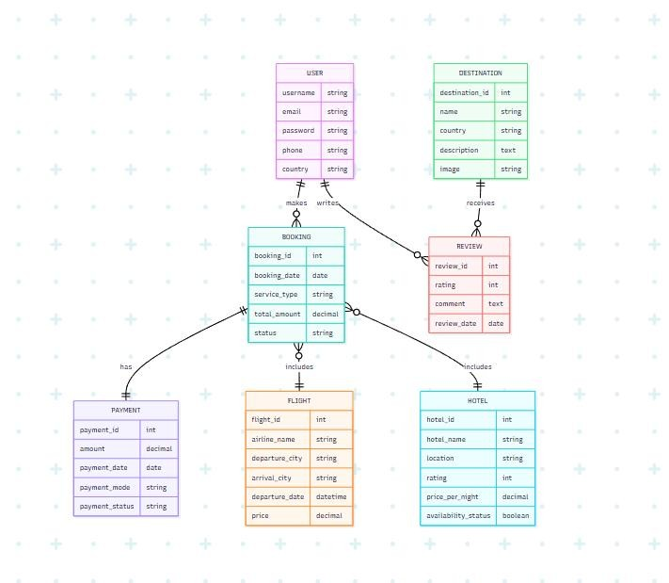

CHAPTER -6 IMPLEMENTATION

6.1 Module-wise Implementation

The Women Safety App with SOS & Live Tracking is implemented using multiple modules, with each module responsible for a specific function of the application. The modular approach helps in organizing the system, simplifying development, and making individual components easier to maintain and enhance.

The major modules implemented in the application are:

1. User Authentication Module

This module manages user registration and login. It verifies user credentials and provides access to authorized users. Authentication helps protect personal information and prevents unauthorized access to the application.

2. User Dashboard Module

The dashboard provides the main interface after successful login. It gives users quick access to important safety features such as SOS, emergency contacts, and live location tracking.

3. Emergency Contact Module

This module allows users to add and manage trusted contacts. Users can add contact details such as name, phone number, and relationship. These contacts are used when an emergency alert needs to be communicated.

4. SOS Alert Module

The SOS module is one of the primary components of the application. When the user activates the SOS button, the system processes the emergency request and initiates the required alert and location-sharing operations.

5. Live Location Tracking Module

This module obtains the user's geographical location using location services. Latitude and longitude information can be used to identify the user's current position and support location sharing during an emergency.

6. Backend API Module

The backend module handles communication between the frontend and database. It provides REST APIs for authentication, emergency contacts, SOS alerts, and location-related operations.

7. Database Management Module

This module manages the storage and retrieval of application data using PostgreSQL. It maintains user information, emergency contacts, SOS alert records, and location data.

8. Notification and Alert Module

This module is responsible for processing emergency-related notifications and alert information. It helps communicate the occurrence of an SOS event to the appropriate trusted contacts.

Module Interaction

The modules work together to provide the complete safety functionality. A typical emergency flow is:

User → SOS Button → Frontend → Backend API → Location Service → Database → Emergency Alert / Trusted Contact

The modular implementation makes the application easier to test, maintain, and extend with additional safety features in the future.

6.2 Front-end Logic (UI Rendering, State Management)

The front-end logic of the Women Safety App with SOS & Live Tracking is responsible for rendering the user interface, handling user interactions, managing application data, and communicating with the backend services. The front-end is developed using React.js, which follows a component-based architecture.

UI Rendering

React.js is used to create reusable components for different parts of the application. The interface dynamically displays information based on the user's actions and the current application state.

The major UI components include:

Login and registration forms.

User dashboard.

SOS emergency button.

Emergency contact management interface.

Live location tracking interface.

Alert and status messages.

Navigation components.

React components allow individual sections of the application to be developed and maintained independently. This improves code organization and makes the interface easier to update.

State Management

State management is used to maintain temporary information required by the application while the user interacts with different features. React state can be used to manage information such as:

Logged-in user information.

Authentication status.

Emergency contact details.

SOS activation status.

Current location.

Loading states.

Error and success messages.

When a state changes, React automatically updates the relevant part of the user interface. For example, when an SOS request is activated, the interface can update the emergency status and display an appropriate message to the user.

User Interaction

The frontend handles different user actions such as button clicks, form submissions, contact management, and SOS activation. Input validation is performed where required before sending information to the backend.

API Communication

The frontend communicates with the backend using REST APIs. It sends requests when users perform operations such as logging in, adding emergency contacts, activating SOS, or requesting location-related functionality. The response received from the backend is then used to update the user interface.

Overall, the front-end logic provides the connection between the user interface, application state, backend APIs, and location services, ensuring that the application responds appropriately to user actions.

6.3 API Integration

API integration in the Women Safety App with SOS & Live Tracking enables communication between the React.js frontend and the Node.js/Express.js backend. The application uses REST APIs to exchange data between the client and server.

When a user performs an operation on the frontend, such as logging in, adding an emergency contact, or activating an SOS alert, the frontend sends an HTTP request to the appropriate backend API. The backend processes the request, performs the required operation, and sends a response back to the frontend.

The major API operations include:
API Function | Purpose
Registration API | Creates a new user account.
Login API | Verifies user credentials and provides authenticated access.
Emergency Contact API | Adds, retrieves, updates, or deletes trusted contacts.
SOS API | Processes an emergency SOS request.
Location API | Handles the user's location information for tracking.
User API | Retrieves or updates user-related information.

API Request and Response Flow

The general communication process is:

React.js Frontend → HTTP Request → Express.js API → Business Logic → PostgreSQL → API Response → React.js Frontend

For example, when the user activates the SOS button, the frontend sends an SOS request to the backend. The backend validates the request, processes the emergency information, stores the required data in PostgreSQL, and returns a response indicating whether the operation was successful.

API Integration Features

Uses RESTful API architecture for frontend-backend communication.

Uses HTTP methods such as GET, POST, PUT, and DELETE according to the operation.

Sends and receives structured data, typically in JSON format.

Performs request validation before processing data.

Handles successful responses and error responses.

Supports authentication for protected operations.

Connects application operations with the PostgreSQL database.

API integration provides a clear separation between the frontend and backend, allowing each layer to be developed and maintained independently. It also makes the application easier to extend with additional features and external services in the future.

6.4 Authentication & Authorization

Authentication and authorization are important security components of the Women Safety App with SOS & Live Tracking. They help protect user accounts and ensure that application data and features are accessed only by authorized users.

Authentication is the process of verifying the identity of a user. When a user registers, the required account information is stored in the database. During login, the entered credentials are verified by the backend. If the credentials are valid, the user is allowed to access the application.

Authorization determines which resources and operations an authenticated user is permitted to access. Protected operations such as viewing personal information, managing emergency contacts, and accessing user-specific SOS or location data should be available only to the appropriate authenticated user.

The authentication and authorization process generally follows these steps:

The user enters their login credentials through the frontend.

The frontend sends the credentials to the backend through a secure API request.

The backend validates the submitted credentials.

If the credentials are valid, authenticated access is provided to the user.

Protected API requests are checked before the requested operation is performed.

The backend verifies that the requested data belongs to the authenticated user.

Unauthorized or invalid requests are rejected with an appropriate error response.

The major security measures include:

User Authentication: Verifies the identity of registered users.

Protected API Routes: Restricts access to sensitive backend operations.

Input Validation: Checks user-provided data before processing.

Password Protection: User passwords should be stored securely rather than as plain text.

Session / Token Management: Maintains authenticated access between the frontend and backend.

User-specific Data Access: Prevents one user from accessing another user's private information.

Error Handling: Provides appropriate responses for invalid credentials and unauthorized requests.

Authentication and authorization therefore provide an essential security layer for protecting user accounts, emergency contacts, SOS records, and location-related information within the application.

CHAPTER 7- FEATURES

7.1 List of Main Features

The Women Safety App with SOS & Live Tracking provides a collection of safety-oriented features designed to help users communicate emergencies and share their location with trusted contacts. The major features of the application are:

User Registration and Login
Allows users to create an account and securely access the application.

User Dashboard
Provides a centralized interface from which users can access the major safety features.

SOS Emergency Alert
Provides a quick-access SOS button that allows the user to initiate an emergency alert when assistance is required.

Emergency Contact Management
Allows users to add, view, update, and manage trusted contacts.

Live Location Tracking
Uses location services to obtain the user's geographical position and support real-time location sharing during emergencies.

Emergency Notifications
Provides emergency-related alert information when an SOS event is triggered.

Location Sharing
Enables relevant location information to be communicated to trusted contacts during an emergency.

Secure Authentication
Protects user accounts through authentication and controlled access to application resources.

Backend API Communication
Provides communication between the frontend and backend for user, contact, SOS, and location-related operations.

Database Management
Stores and manages user information, emergency contacts, SOS alerts, and location records.

Responsive User Interface
Provides a simple and accessible interface that can be used across supported screen sizes.

Emergency Status Updates
Displays appropriate status information to the user regarding SOS activation, location sharing, and other emergency operations.

These features work together to provide a centralized safety platform that helps users quickly access emergency assistance and communicate important information with trusted contacts.
7.2 How Each Feature Works (User Perspective + Technical Description)
The features of the Women Safety App with SOS & Live Tracking are designed to provide a simple user experience while performing the required operations through the frontend, backend, database, and location services.
1. User Registration and Login
User Perspective:
The user creates an account by entering the required details and can later log in using their registered credentials.
Technical Description:
The React.js frontend collects the registration or login details and sends them to the backend through REST APIs. The Node.js and Express.js backend validates the information and communicates with PostgreSQL for storing or retrieving user data.
2. User Dashboard
User Perspective:
After logging in, the user can access the main safety features from the dashboard.
Technical Description:
The dashboard is implemented using React components. It provides navigation to emergency contacts, SOS functionality, location tracking, and other application features.
3. SOS Emergency Alert
User Perspective:
When the user feels unsafe or faces an emergency, they can press the SOS button to initiate an emergency alert.
Technical Description:
The frontend sends an SOS request to the backend through an API. The backend processes the request and records the emergency event in the database. The system can then use the user's location and emergency-contact information for further alert processing.
4. Emergency Contact Management
User Perspective:
The user can add trusted people such as family members or friends as emergency contacts and manage their details.
Technical Description:
Contact information is submitted through the React.js interface and sent to the backend. The backend validates the information and stores it in the PostgreSQL database with a relationship to the corresponding user.
5. Live Location Tracking
User Perspective:
During an emergency, the user can share their current location so that trusted contacts can identify where they are.
Technical Description:
The application uses the device's location services to obtain geographical coordinates such as latitude and longitude. The location information is sent through the backend and can be associated with the relevant SOS event.
6. Emergency Notifications
User Perspective:
The user receives status information when an emergency action is initiated or processed.
Technical Description:
The backend processes the SOS event and provides the required response to the frontend. The frontend displays the appropriate alert or status message to the user.
7. Secure Authentication
User Perspective:
Only registered and authenticated users can access protected features of the application.
Technical Description:
The backend verifies login credentials and manages authenticated access. Protected API routes check the user's authentication status before allowing access to user-specific information.
8. Database Management
User Perspective:
The user does not directly interact with the database, but their information and safety-related activities are stored for application functionality.
Technical Description:
PostgreSQL stores user details, emergency contacts, SOS records, and location information. The backend performs database operations through appropriate queries.
9. API Communication
User Perspective:
The user interacts with the application normally without needing to know how data is transferred between system components.
Technical Description:
REST APIs provide communication between the React.js frontend and Node.js/Express.js backend. Requests and responses are exchanged using standard HTTP methods and structured data.
Overall, these features work together to provide a simple emergency-response workflow, where the user can trigger an SOS, provide location information, and communicate with trusted contacts while the backend and database manage the required processing and data.

CHAPTER -8 TESTING

8.1 Postman Testing (Frontend/Backend)

Postman is used to test and validate the REST APIs of the Women Safety App with SOS & Live Tracking. It helps verify whether the backend receives requests correctly, processes the required operations, communicates with the database, and returns the expected responses.

The frontend is not directly tested through Postman. Instead, the API endpoints used by the frontend are tested independently to ensure that the backend services are functioning correctly before or during frontend integration.

The major API operations tested using Postman include:
Test | HTTP Method | Purpose
User Registration | POST | Checks whether a new user can be registered successfully.
User Login | POST | Verifies user credentials and authentication response.
Add Emergency Contact | POST | Checks whether a trusted contact can be added.
Get Emergency Contacts | GET | Retrieves the contacts associated with a user.
Update Emergency Contact | PUT | Verifies whether contact information can be modified.
Delete Emergency Contact | DELETE | Checks whether an existing contact can be removed.
Trigger SOS | POST | Tests the emergency SOS request processing.
Location Update | POST / PUT | Tests sending location information to the backend.
Get User Data | GET | Checks retrieval of user-specific information.

Testing Process

The API testing process involves the following steps:

Start the Node.js and Express.js backend server.

Open Postman and create a request for the required API endpoint.

Select the appropriate HTTP method such as GET, POST, PUT, or DELETE.

Provide the required request parameters, headers, or JSON body.

Send the request to the backend.

Verify the HTTP status code and response data.

Check whether the corresponding database operation was performed correctly.

Test invalid inputs and unauthorized requests to verify error handling.

Postman testing helps identify issues such as incorrect API routes, invalid request data, authentication problems, database errors, and unexpected server responses.

The API testing results are recorded and compared with the expected results to ensure that the backend functions correctly before final integration with the frontend.

8.2 Integration Testing

Integration testing is performed to verify whether the different components of the Women Safety App with SOS & Live Tracking work correctly when connected together. It ensures proper communication between the frontend, backend, database, and external location services.

The major integration areas tested are:

Frontend and Backend Integration
The React.js frontend is connected with the Node.js and Express.js backend through REST APIs. Requests sent from the frontend are checked to ensure that the backend receives and processes them correctly.

Backend and Database Integration
The backend is connected with PostgreSQL to store and retrieve application data. Operations such as user registration, login, emergency contact management, SOS alerts, and location records are verified.

Authentication Integration
The login process is tested from the frontend through the backend to ensure that valid users can access protected features and invalid credentials are rejected.

SOS and Location Integration
When the user activates the SOS feature, the system is tested to verify that the SOS request and relevant location information are processed correctly.

Emergency Contact Integration
The emergency contact information entered through the frontend is checked to ensure that it is correctly sent to the backend and stored in the database.

Location Service Integration
The location service is tested to verify that the user's latitude and longitude can be obtained and processed correctly by the application.

Error Handling Integration
Invalid inputs, failed API requests, unavailable services, and unauthorized requests are tested to ensure that appropriate error messages are displayed.

The integration testing confirms that the individual modules operate together as a complete system. It helps identify communication errors between components and ensures that data flows correctly throughout the application.

8.3 Tools Used for Testing

The Women Safety App with SOS & Live Tracking uses different testing tools and techniques to verify the functionality, reliability, and performance of the application.

The major testing tools used are:

Postman
Used to test REST APIs, including user registration, login, emergency contacts, SOS alerts, and location-related requests.

Web Browser Developer Tools
Browser developer tools are used to inspect the frontend, identify UI issues, check console errors, and monitor network requests between the frontend and backend.

React Testing / Browser Testing
The React.js interface is tested by interacting with different screens, buttons, forms, and navigation components to verify that they work as expected.

PostgreSQL / Database Tools
Database tools are used to verify whether user details, emergency contacts, SOS records, and location information are correctly stored and retrieved.

Git and GitHub
Git is used to track code changes and maintain different versions of the application during development and testing.

Manual Testing
Important application workflows are manually tested from the user's perspective to verify the complete functionality of the system.

These tools help identify functional errors, API issues, database problems, UI errors, and integration issues during the development process. Testing the application using multiple approaches helps ensure that the major features work correctly before deployment.

8.4 Test Cases and Results

Test cases are used to verify whether the major features of the Women Safety App with SOS & Live Tracking work correctly according to the expected requirements. Testing was performed by providing different valid and invalid inputs and observing the behavior of the application.

User registration was tested by entering valid user details. The application successfully accepted the information and created the user account. Invalid and incomplete registration details were also tested, and appropriate validation messages were displayed.

The login functionality was tested using valid credentials. The application successfully authenticated the user and provided access to the dashboard. Incorrect login credentials were also tested, and the system rejected the request and displayed an appropriate error message.

The emergency contact feature was tested by adding valid contact details. The contact was successfully stored and displayed in the emergency contacts section. Updating and deleting existing contacts were also tested successfully.

The SOS feature was tested by activating the emergency button. The application successfully processed the SOS request and displayed the appropriate emergency status. This test verified the communication between the frontend and backend.

The location tracking functionality was tested by allowing location access on the device. The application successfully obtained the user's geographical location. Location information such as latitude and longitude was checked to ensure that it was processed correctly.

The backend APIs were tested using Postman. Valid requests returned the expected responses, while invalid requests were checked to ensure that appropriate error responses were generated.

Authentication and authorization were also tested by attempting to access protected features with and without valid authentication. Unauthorized access was restricted as expected.

Database operations were tested by adding, retrieving, updating, and deleting application data. The data was verified to ensure that the required information was stored and retrieved correctly.

The application interface was tested on different screen sizes to verify responsiveness and usability. The major interface components remained accessible and properly arranged.

Overall, the test results showed that the major features of the application performed as expected. Testing helped identify and resolve issues related to user input, API communication, authentication, database operations, SOS processing, and location services.

CHAPTER -9 DEPLOYMENT
9.1 Steps to Deploy
The deployment of the Women Safety App with SOS & Live Tracking involves preparing the frontend, backend, database, and required environment configurations so that the application can be accessed and used outside the development environment.
The general deployment process is as follows:
- Prepare the Project
Ensure that the frontend and backend source code is complete and all required dependencies are properly configured.
- Test the Application
Test the major features such as registration, login, emergency contacts, SOS alerts, location tracking, API communication, and database operations.
- Configure the Database
Create the required PostgreSQL database and tables. Configure the database connection details required by the backend.
- Configure the Backend
Install the required Node.js dependencies and configure the backend environment variables. Verify that the Express.js server can connect successfully to the database.
- Build the Frontend
Create the production build of the React.js application using the appropriate build command. This generates optimized files required for deployment.
- Deploy the Backend
Upload or deploy the Node.js and Express.js backend to the selected hosting/server environment. Configure the required environment variables and verify that the API endpoints are accessible.
- Deploy the Frontend
Deploy the React.js production build to the selected frontend hosting platform and configure it to communicate with the deployed backend API.
- Configure API Connections
Update the frontend API configuration so that requests are sent to the correct production backend URL instead of the local development server.
- Test the Deployed Application
Open the deployed application and verify registration, login, emergency contact management, SOS functionality, location tracking, and backend communication.
- Monitor and Maintain
After deployment, monitor the application for errors and performance issues. Updates can be made through the version-control repository and redeployed when required.
The deployment process ensures that all components of the application are correctly configured and connected, allowing users to access the Women Safety App through the deployed application environment.

9.2 Environment Configuration

Environment configuration is required to ensure that the Women Safety App with SOS & Live Tracking operates correctly in the development and deployment environments. Configuration values such as database connections, server settings, API URLs, and authentication-related information should be managed separately from the application source code.

The main environment configuration requirements include:

Backend server configuration such as the port number and server environment.

PostgreSQL database configuration including database name, username, password, host, and port.

Frontend configuration for connecting to the backend API.

Authentication-related configuration required by the backend.

Location service or API configuration required for obtaining geographical information.

Environment-specific settings for development and production.

Sensitive information such as database passwords, authentication keys, secret keys, and API credentials should not be directly written inside the source code. Instead, these values can be stored in environment variables, commonly through a .env file during development.

A typical configuration process includes creating the required environment variables, loading them into the backend application, configuring the database connection, and specifying the correct backend API address in the frontend.

During local development, the frontend communicates with the locally running backend server. During production deployment, the frontend configuration must be updated to use the URL of the deployed backend server.

Proper environment configuration improves application security, simplifies deployment, and allows the same source code to be used across different environments with different configuration values.

9.3 Hosting of Frontend and Backend
The hosting process makes the Women Safety App with SOS & Live Tracking accessible to users through the internet. The application consists of a React.js frontend, Node.js and Express.js backend, and PostgreSQL database.
The frontend can be hosted on a web hosting or cloud platform that supports React.js applications. After creating the production build, the generated frontend files are uploaded or connected to the hosting service. The hosted frontend provides the user interface through which users access the application.
The backend is hosted separately on a server or cloud platform that supports Node.js applications. The Node.js and Express.js server handles API requests from the frontend, performs application logic, communicates with the PostgreSQL database, and returns responses to the frontend.
The PostgreSQL database can be hosted on a database server or managed cloud database service. The backend is configured with the database connection details using environment variables.
The overall hosting structure is:
User Device → Hosted React.js Frontend → Node.js/Express.js Backend → PostgreSQL Database
The frontend and backend communicate through REST APIs using HTTPS. The frontend is configured with the deployed backend API address so that user requests are sent to the correct server.
After hosting, the complete application should be tested in the production environment to verify that user authentication, emergency contacts, SOS alerts, location tracking, API communication, and database operations work correctly.
This hosting architecture separates the presentation, processing, and data-storage components, making the application easier to maintain and allowing individual components to be updated or scaled when required.

CHAPTER -10 CHALLENGES & LIMITATIONS

10.1 Issues Faced During Development

During the development of the Women Safety App with SOS & Live Tracking, several technical and practical challenges were encountered while implementing and integrating the different components of the application.

The major issues faced during development include:

Frontend and Backend Integration
Connecting the React.js frontend with the Node.js and Express.js backend required proper API configuration and request handling. Incorrect API endpoints or configuration issues could prevent communication between the two layers.

Database Connectivity
Establishing a stable connection between the backend and PostgreSQL database required correct database credentials, connection settings, and query handling.

User Authentication
Implementing secure registration and login functionality required proper validation of user credentials and protection of authenticated routes.

SOS Functionality
Designing the SOS feature required ensuring that the emergency request was processed correctly and that the required user and emergency information was available when the SOS button was activated.

Location Access
Obtaining the user's location depends on device permissions and location services. Permission denial or unavailable location services can affect the tracking functionality.

Real-Time Location Handling
Managing location updates while maintaining reliable communication between the frontend and backend was a challenge during implementation.

API Testing and Error Handling
Different API requests had to be tested with valid and invalid inputs. Handling incorrect requests, server errors, and database failures required additional validation and error-handling logic.

Responsive User Interface
Designing an interface that remains easy to use across different screen sizes required adjustments to layouts, components, and styling.

Data Security
Protecting sensitive information such as user credentials, emergency contacts, and location data required careful handling of authentication and database access.

Deployment Configuration
Moving the application from the local development environment to a deployment environment required configuration of environment variables, API URLs, database connections, and hosting settings.

These challenges provided practical experience in frontend development, backend programming, database management, API integration, authentication, location services, testing, and deployment.

10.2 Solutions Applied

The challenges encountered during the development of the Women Safety App with SOS & Live Tracking were addressed by applying appropriate technical solutions and following a systematic development and testing process.

Frontend and Backend Integration
API endpoints were properly configured and tested to establish reliable communication between the React.js frontend and Node.js/Express.js backend.

Database Connectivity
The PostgreSQL connection configuration was verified, and database queries were tested to ensure that data could be stored and retrieved correctly.

User Authentication
Input validation and authentication mechanisms were implemented to verify user credentials and restrict unauthorized access to protected resources.

SOS Functionality
The SOS workflow was tested from the frontend to the backend to ensure that the emergency request was received, processed, and recorded correctly.

Location Access
Location permissions were handled appropriately, and the application was tested to ensure that geographical coordinates could be obtained when location access was available.

Real-Time Location Handling
Location data was processed through the application's API layer, allowing the frontend and backend to exchange the required tracking information.

API Errors and Validation
Postman was used to test different API requests. Validation and error-handling mechanisms were added to manage invalid inputs and unsuccessful requests.

Responsive Interface
Responsive layouts and reusable React components were used to improve the application's usability across different screen sizes.

Data Security
Sensitive information was handled through controlled backend access and environment configuration. Protected resources were restricted to authenticated users.

Deployment Issues
Environment variables and production configuration were separated from development settings. API URLs and database connection settings were configured according to the deployment environment.

These solutions helped improve the reliability, maintainability, security, and usability of the application and allowed the different components to work together as an integrated system.

10.3 Current Limitations or Known Bugs
Although the Women Safety App with SOS & Live Tracking provides important emergency and location-based features, the current version has certain limitations that can be improved in future versions.
- Internet Dependency
The application requires an active internet connection for communication with the backend, database, and other online services. Limited or unavailable connectivity may affect emergency communication.
- GPS Accuracy
The accuracy of the user's location depends on the device's GPS capability and environmental conditions. Indoor environments or weak GPS signals may result in less accurate location information.
- Device Permissions
Location-based features require the user to provide the necessary device permissions. If location access is denied, live tracking may not function properly.
- Battery Consumption
Continuous location tracking may consume additional battery power, particularly when tracking is active for a long period.
- Emergency Contact Dependency
The effectiveness of the emergency alert system depends on the availability and responsiveness of the configured trusted contacts.
- Limited Emergency Service Integration
The current application does not provide direct integration with police, ambulance, or other official emergency response services.
- Notification Limitations
Emergency notifications may be affected by network availability, device settings, notification permissions, or background application restrictions.
- Platform Limitations
Certain device-specific location and notification behaviors may vary depending on the operating system, browser, or device configuration.
- Limited Automated Detection
The current version primarily depends on the user manually activating the SOS feature. Automatic detection of accidents, falls, or dangerous situations is not fully implemented.
- Scalability Considerations
If the number of users increases significantly, the backend, database, and location-processing services may require additional optimization and infrastructure.
These limitations do not prevent the core application from demonstrating its intended functionality, but addressing them in future versions can make the system more reliable, secure, and effective for real-world use.

CHAPTER -11 FUTURE ENHANCEMENTS

11.1 Planned Features

The current version of the Women Safety App with SOS & Live Tracking can be further improved by adding advanced features that provide faster emergency assistance, better location awareness, and improved user convenience.

The planned features include:

Voice-Activated SOS
Users can trigger an SOS alert using a predefined voice command when they are unable to operate the application manually.

Shake-to-Activate SOS
An emergency alert can be triggered by shaking the smartphone, providing an alternative method of activating SOS.

Nearby Safe Locations
The application can identify nearby police stations, hospitals, and other safe locations based on the user's current location.

Direct Emergency Service Integration
The system can be integrated with police, ambulance, and other emergency services to improve the emergency response process.

Automatic Accident Detection
Smartphone sensors can be used to detect possible falls or accidents and initiate an emergency alert when required.

Improved Live Tracking
Continuous location updates can be provided to authorized emergency contacts during an active emergency.

Emergency Calling
A quick emergency calling option can be provided so that users can contact emergency services directly from the application.

Wearable Device Integration
The application can be connected with smartwatches and other wearable devices to allow users to trigger safety features without directly accessing their smartphone.

Offline Emergency Support
Future versions can explore mechanisms for providing limited emergency functionality when internet connectivity is unavailable.

AI-Based Safety Assistance
Artificial intelligence can be incorporated to identify unusual or potentially risky situations and provide appropriate safety recommendations.

These planned features can make the application more comprehensive and improve its ability to support users during different types of emergency situations.

11.2 Possible Integrations or Optimisations
The Women Safety App with SOS & Live Tracking can be further improved by integrating additional technologies and optimizing the existing system. These improvements can increase the application's performance, reliability, security, and scalability.
The possible integrations and optimizations include:
- AI-Based Risk Detection
Artificial intelligence can be integrated to analyze location patterns and identify potentially unsafe situations, providing users with suitable safety recommendations.
- Emergency Service Integration
The application can be integrated with police, ambulance, and other emergency services to provide faster assistance during critical situations.
- Maps Integration
A mapping service can be integrated to display the user's live location, routes, nearby safe places, police stations, and hospitals.
- Wearable Device Integration
Smartwatches and other wearable devices can be connected to allow users to trigger SOS alerts and share location information quickly.
- Cloud Optimization
Cloud-based services can be used to improve system availability, scalability, and data management as the number of users increases.
- Database Optimization
Database indexing, efficient queries, and proper database design can improve the speed of storing and retrieving user, SOS, contact, and location information.
- API Optimization
Backend APIs can be optimized to reduce response time and efficiently handle multiple requests.
- Enhanced Security
Additional security mechanisms such as stronger authentication, secure data transmission, and improved access control can be implemented to protect sensitive user and location information.
- Improved Notification System
A reliable notification service can be integrated to deliver emergency alerts quickly to trusted contacts.
- CI/CD Automation
Automated testing and deployment pipelines can be implemented to reduce manual deployment effort and ensure that application updates are delivered consistently.
These integrations and optimizations can make the application more secure, scalable, efficient, and reliable, while also providing opportunities to expand its functionality in future versions.
CHAPTER 12 – CONCLUSION
12.1 Summary of the Project
The Women Safety App with SOS & Live Tracking is a web-based safety application developed to provide users with a quick and accessible method of seeking assistance during emergency situations. The project focuses on combining emergency alert functionality, trusted contact management, and location tracking into a single platform.
The application allows users to register and log in to their accounts, manage trusted emergency contacts, and access the SOS feature through the dashboard. When an emergency occurs, the user can activate the SOS function, allowing the system to process the emergency request and use the available location information to support communication with trusted contacts.
The system is designed using a layered architecture consisting of the frontend, backend, database, and external services. The frontend is developed using React.js and provides the user interface for interacting with the application. The backend is developed using Node.js and Express.js and is responsible for business logic, authentication, API handling, and communication with the database. PostgreSQL is used to store and manage user information, emergency contacts, SOS records, and location data.
REST APIs provide communication between the frontend and backend. Location services are used to obtain geographical information such as latitude and longitude. The application is tested using Postman, manual testing, integration testing, and database verification to ensure that the major functionalities operate correctly.
The project also focuses on usability and accessibility by providing a simple interface and quick access to important safety features. Proper authentication and authorization mechanisms help protect user-specific information and restrict unauthorized access.

Through this project, a functional foundation for a personal safety platform has been developed. The system can be further extended with features such as direct emergency-service integration, nearby safe-location detection, voice-activated SOS, automatic accident detection, wearable-device integration, AI-based risk detection, and improved offline support.

Overall, the project demonstrates the practical application of React.js, Node.js, Express.js, PostgreSQL, REST APIs, authentication, and location-based services to address a real-world safety requirement.

12.2 What Was Achieved

The development of the Women Safety App with SOS & Live Tracking resulted in the implementation of the major components required for a technology-based personal safety application.

The following outcomes were achieved during the project:

A user-friendly interface was developed using React.js for accessing the application's major safety features.

User registration and login functionality was implemented to provide authenticated access to the application.

An SOS emergency feature was developed to allow users to quickly initiate an emergency request.

An emergency contact management feature was implemented to allow users to maintain trusted contacts.

Location-based functionality was incorporated to obtain the user's geographical location and support live tracking.

A Node.js and Express.js backend was developed to handle application logic and provide REST APIs.

PostgreSQL was integrated to store and manage user details, emergency contacts, SOS records, and location information.

Frontend and backend communication was established using REST APIs.

Authentication and authorization mechanisms were incorporated to protect user-specific information and application resources.

API testing and integration testing were performed to verify the functionality and communication between different system components.

Git and GitHub were used for source-code management and tracking development changes.

The application architecture was designed in a modular and scalable manner so that additional safety features can be incorporated in future versions.

Overall, the project successfully demonstrated the development and integration of frontend, backend, database, API, authentication, and location-based components into a unified women safety application.

12.3 Skills Learned During Development
The development of the Women Safety App with SOS & Live Tracking provided practical experience in different areas of software development. The project helped in understanding how individual technologies can be integrated to create a complete real-world application.
The major skills learned during the development process include:
- Front-end Development
Gained practical knowledge of React.js, component-based development, UI design, responsive layouts, and handling user interactions.
- Back-end Development
Learned how to develop server-side applications using Node.js and Express.js and how to implement application logic.
- REST API Development and Integration
Learned how to create, consume, and test REST APIs for communication between frontend and backend.
- Database Management
Gained experience in designing database tables, establishing relationships, writing queries, and managing application data using PostgreSQL.
- Authentication and Authorization
Learned the importance of user authentication, protected resources, access control, and secure handling of user information.
- Location-Based Services
Gained an understanding of GPS, geographical coordinates, and location-based functionality required for live tracking.
- API Testing
Learned how to use Postman to test API requests, responses, validation, and error handling.
- Git and GitHub
Developed skills in version control, maintaining repositories, tracking changes, and managing project source code.
- System Design and Architecture
Learned how to divide an application into frontend, backend, database, and external-service layers and understand how these components communicate.
- Problem Solving and Debugging
Developed the ability to identify technical issues, analyze errors, test possible solutions, and improve the application's functionality.
- Team Collaboration
Gained experience in coordinating development activities, sharing code, managing tasks, and working together toward a common project goal.
- Project Documentation
Learned how to document system requirements, architecture, implementation, testing, limitations, and future enhancements in a structured technical format.
Overall, the project provided practical knowledge of the complete software development process, from planning and design to implementation, testing, version control, and deployment.

CHAPTER 13 - REFERENCES
Books
Pressman, R. S., & Maxim, B. R. (2019). Software Engineering: A Practitioner’s Approach (8th ed.). McGraw-Hill Education.
Sommerville, I. (2016). Software Engineering (10th ed.). Pearson Education.
Duckett, J. (2015). JavaScript and JQuery: Interactive Front-End Web Development. Wiley.
Freeman, E., & Robson, E. (2020). Head First JavaScript Programming. O’Reilly Media.
Flanagan, D. (2020). JavaScript: The Definitive Guide (7th ed.). O’Reilly Media.

Tutorials and Learning Resources
W3Schools. (2025). React.js, JavaScript, HTML, CSS, and Web Development Tutorials. Retrieved from W3Schools
MDN Web Docs. (2025). Web Technologies Documentation. Retrieved from MDN Web Docs
freeCodeCamp. (2025). React.js, JavaScript, and Web Development Tutorials. Retrieved from freeCodeCamp
GeeksforGeeks. (2025). React.js, Node.js, Express.js, PostgreSQL, and Web Development Resources. Retrieved from GeeksforGeeks
TutorialsPoint. (2025). React.js, Node.js, Express.js, and Web Development Tutorials. Retrieved from TutorialsPoint

APIs and Tools Used
React. (2025). React Documentation. Retrieved from React Documentation
Node.js. (2025). Node.js Documentation. Retrieved from Node.js Documentation
Express.js. (2025). Express.js Web Framework Documentation. Retrieved from Express.js
PostgreSQL. (2025). PostgreSQL Documentation. Retrieved from PostgreSQL Documentation
Postman. (2025). Postman API Platform Documentation. Retrieved from Postman Documentation
GitHub. (2025). GitHub Documentation. Retrieved from GitHub Documentation
Git. (2025). Git Documentation. Retrieved from Git Documentation

Location and Safety Technology References
MDN Web Docs. (2025). Geolocation API Documentation. Retrieved from Geolocation API Documentation
Google Maps Platform. (2025). Maps JavaScript API Documentation. Retrieved from Google Maps Platform Documentation
Google Firebase. (2025). Firebase Documentation and Services. Retrieved from Firebase Documentation

Documentation and Research References
World Health Organization. (2024). Violence Against Women. Retrieved from World Health Organization
United Nations Women. (2024). Ending Violence Against Women. Retrieved from UN Women
Ministry of Home Affairs, Government of India. (2024). Emergency Response Support System (ERSS) – 112 India. Retrieved from 112 India

Development and Testing Resources
Postman. (2025). API Testing and Development Documentation. Retrieved from Postman Learning Center
npm. (2025). Node Package Manager Documentation. Retrieved from npm Documentation
Vite. (2025). Vite Documentation. Retrieved from Vite Documentation
This version is much more suitable for your project because it references React.js, Node.js, Express.js, PostgreSQL, REST APIs, Git/GitHub, Postman, and Geolocation, rather than unrelated travel/weather APIs.

CHAPTER -14 APPENDICES

Screenshots of the app
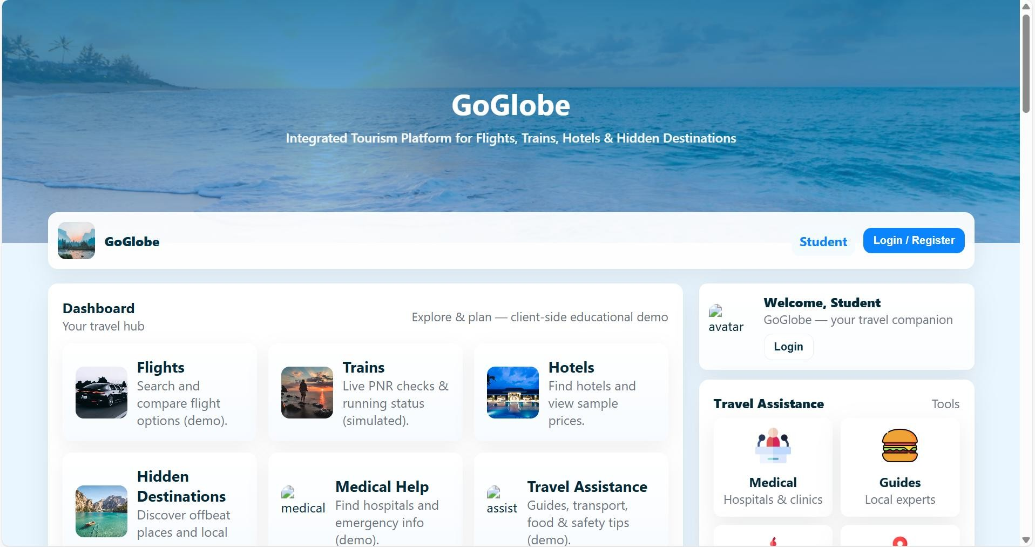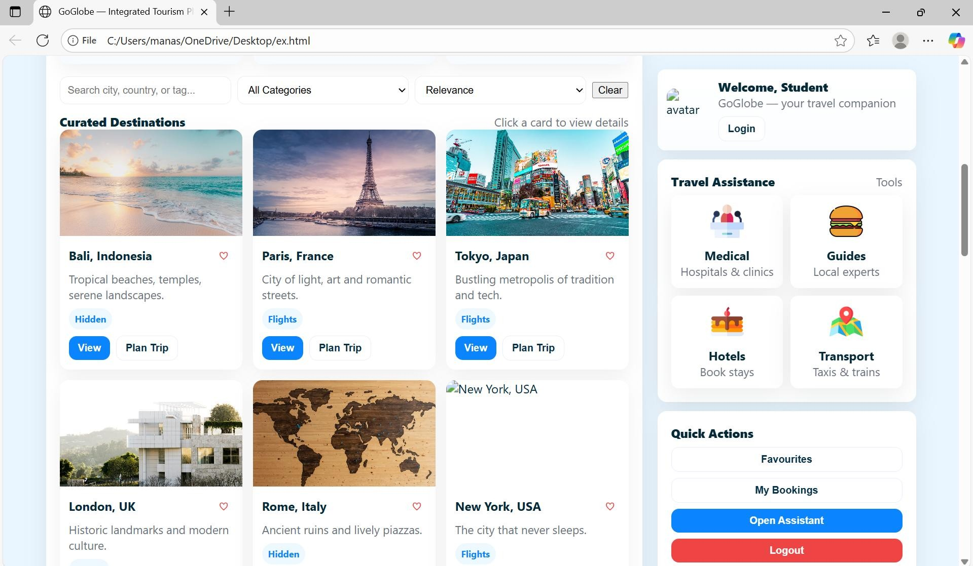

Sample code snippets
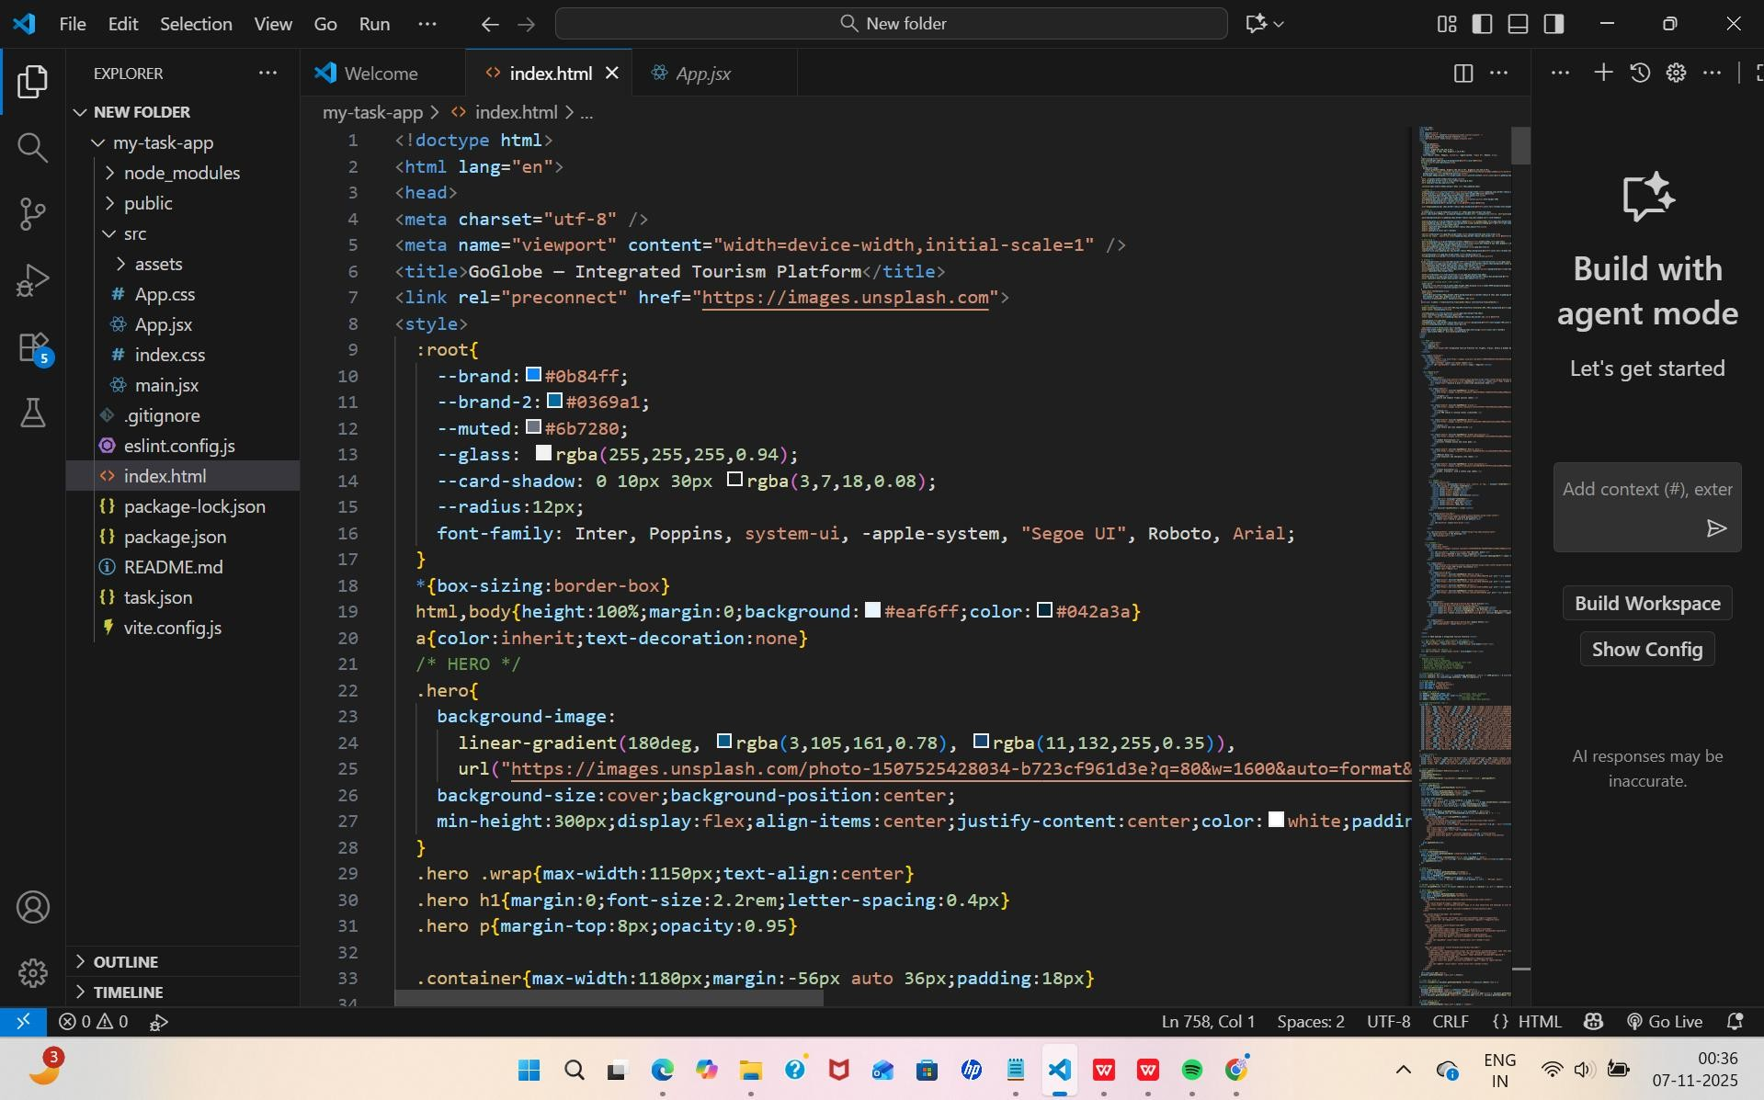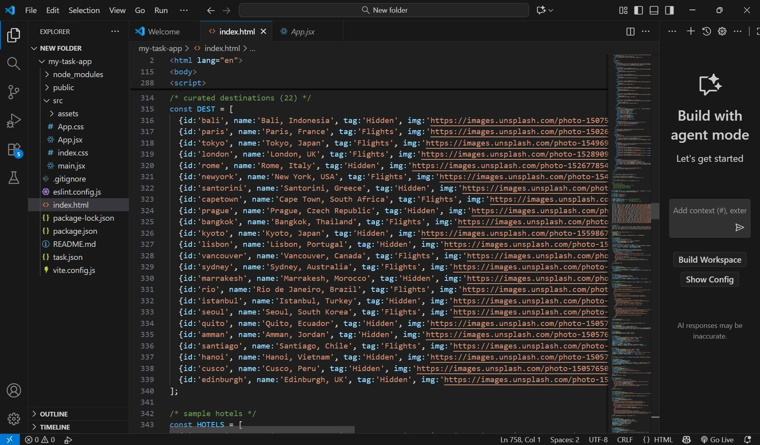

Installation/setup instructions
The GOglobe Integrated Tourism Platform is simple to install because it is built entirely using HTML, CSS, and JavaScript. It does not require any external frameworks or databases. The setup can be completed in just a few steps.
First, download or copy the complete GOglobe project folder to your local computer. If it is shared as a ZIP file, extract it using any standard extraction tool. Make sure all files especially index.html, style.css, and script.js (if included) are in the same folder.
Next, open the folder in a text editor like Visual Studio Code or Sublime Text to review or modify the code. To run the project, simply double-click on the index.html file or right-click and select “Open with Browser.” The website will open and function in any modern browser such as Google Chrome, Microsoft Edge, or Firefox.
No installations or dependencies are needed. The project is fully self-contained and works offline, making it ideal for classroom demonstrations and educational submissions. User manual or guide
When you open the GOglobe platform, the homepage displays the main navigation bar with options like Login, Register, Destinations, and Travel Assistance. Users can begin by clicking the Login or Register buttons. A clean, half-page form will appear where users can enter their details to simulate login or registration.
Once logged in, users can explore Top Global Destinations, view beautiful travel images, and get information about each place. The Travel Assistance section offers quick options like medical help, hotel booking, and transportation support all designed for educational simulation.
Navigation through the platform is smooth, with buttons that automatically scroll to their respective sections. Alerts confirm actions such as successful login or registration. The entire experience demonstrates how an integrated tourism platform would look and behave in a real-world environment.

Geo Tag photos with guide

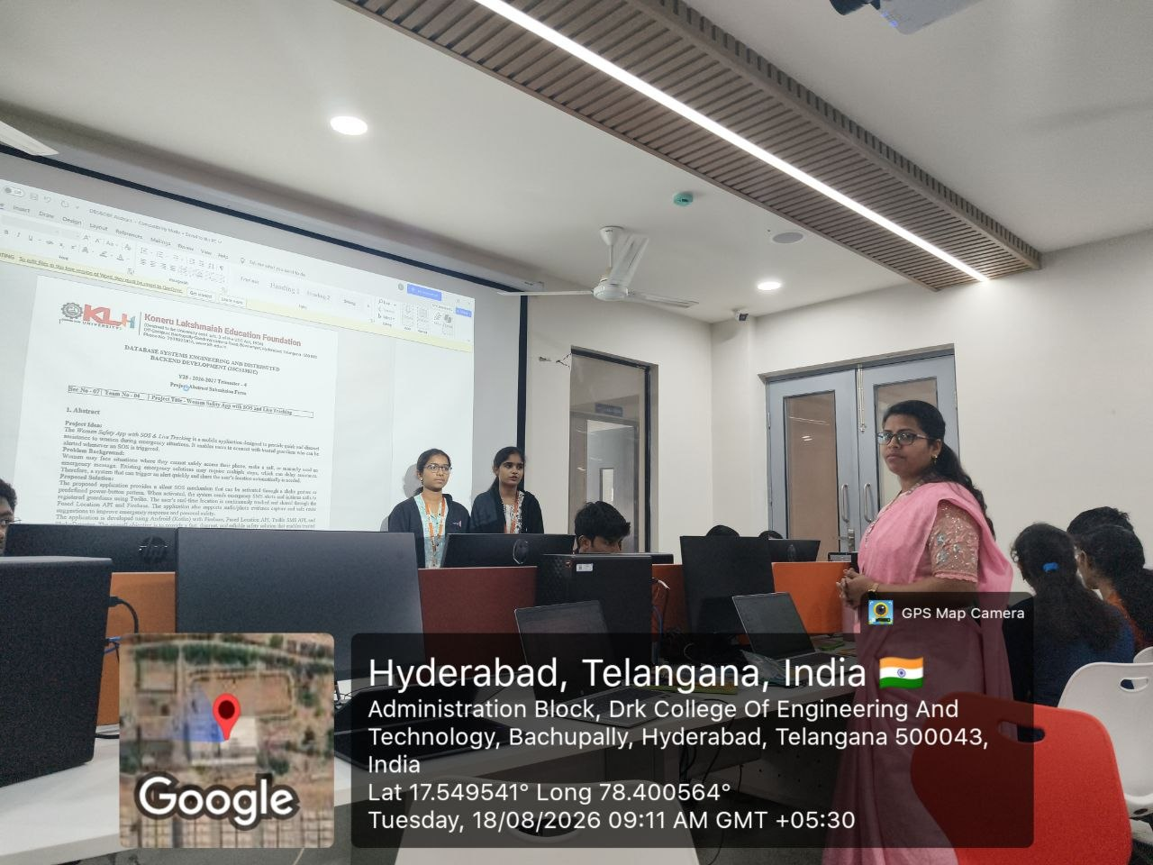

Review forms with guide signatures

